Volunteering at the Games: A Sports Therapy Case Study

Case Study

Volunteering at the 2012 Games
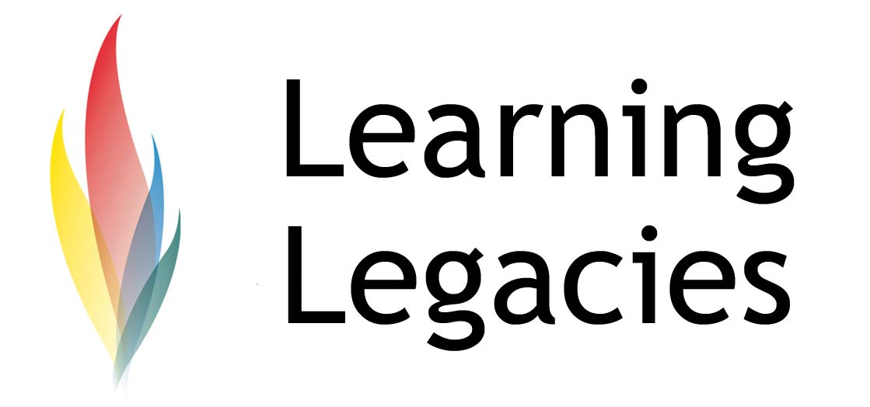

Elite athletes rely on the support of highly qualified teams and specialists to reach their athletic potential. This support takes many forms – physiological (sports therapy, physiologists, masseurs), mental (sports psychology), training (coaches) and nutritive (sports nutritionists). Team GB (both Olympic and Paralympic) rely on such support, but much of this needs to come from voluntary sources. Whilst volunteering is crucial to both Olympic and Paralympic sports, it is particularly important to shine a light on the need for more volunteering in Paralympic and disabled sport, as these sports tend to receive less financial support than their Olympic counterparts. Such a need is compounded by the current financial crisis that is sweeping Europe, and an associated drop in the financial resources available for the funding of grassroots and elite sport.

Volunteering in the Olympic Games
London has already played host to the Olympic Games twice – in 1908 and 1948. The birth of volunteering at the Games actually took place in London at the 1948 Games, following the Blitz that ravaged the capital, a continued use of rationing, and a severely compromised finances with which to host an event such as the Olympics. The London 2012 Games brings the Olympic rings to our shores for a third historic time, and it is fitting that, once again, the capital will depend on an army of up to 70,000 volunteers, to ensure that the Olympic Games and Paralympic Games run smoothly and successfully (in fact, hundreds of thousands of individuals applied to become a volunteer).

Volunteering: A Case Study
As volunteers – particularly specialists – are often in short supply, this case study investigates the experience of one such volunteer, to understand how the role has benefited her, and how others have benefited from her involvement.

Naomi Hewitt, a Senior Lecturer of Sports Therapy, is a faculty member at the University of Hertfordshire School of Sport, Health & Exercise. Naomi has previously worked as a volunteer for young disabled athletes alongside the demands of her faculty position – finding the combination of both to be extremely rewarding and professionally challenging. Her volunteer position involved the support of young athletes with disabilities (aged 10 to 20), who were based at Stevenage and North Hertfordshire Athletics Club. Level of play ranged from recreational to nationally competitive, and her work spanned all areas of athletics (track and field). As a sports therapist, her role centred around the provision of support to injured athletes, including the prevention, assessment, treatment and rehabilitation of injury.

Case Study

Volunteering at the 2012 Games

WOMENS PARTICIPATION IN THE OLYMPIC GAMES

Naomi shares her experiences here and outlines how students can become more involved in volunteering.

- Exactly what did your role involve?
Individual consultations with the athletes (and their parent/guardian if under 18) to assess their needs. Assessment of any injury, and discussion of areas they had particular difficulties with and were keen to improve such as balance, control, functional skills or core stability. These areas may be general or specific to their disability. I would then devise exercise programmes for them to follow and would monitor their progress and develop the programme as necessary.

- What type of disabilities did the young athletes possess and how did you gain the knowledge to effectively deal with such a wide range of disabilities?
Many had CP, lots of different presentations. Limb deficiency – deformities from birth. Klippel-Feil Syndrome – fused cervical spine with separated spinal cord. Hearing impairment. Dyspraxia.

Knowledge was gained from discussions with the athletes themselves – they are the experts when it comes to their individual disabilities. Also their parents and coaches. Background information came from my own experience having worked at a respite centre for children with disabilities and also at a centre for brain injury. Some books, journal articles and disability specific websites were also useful, along with communications with key healthcare professionals involved with the athletes where appropriate.

- As a volunteer, what did you personally get out of the experience?
A huge amount. It was extremely satisfying to be able to support these athletes in making significant improvements in areas they had presumed were permanently limited, or to achieve things they didn’t think possible. Often this made very positive changes not only in their sport but in their day to day lives. Being involved also enabled me to develop my skills as a sports therapist and to learn a great deal about working with athletes with disabilities. This has also contributed to my teaching of students on the BSc Sports Therapy so that they are better prepared to work with all athletes.

- How do you think that more volunteers might be attracted to this kind of activity?
Hearing how much of a difference it can make to the athletes and the satisfaction for those involved may encourage more volunteers. Also if they are aware that all sports professionals can offer something, and that it will be gratefully received.

- Do you think that this type of volunteering could be integrated successfully into degree programmes to provide much needed experience for undergraduates?
Absolutely. I first started with the Activity Buddy Scheme which I think would be a great starting point for undergraduates. Sports therapy students could not practise without insurance, but they could volunteer in another capacity for experience or shadow a qualified professional.

Case Study

WOMENS PARTICIPATION IN THE OLYMPIC GAMES

- Did you find that you faced different challenges or scenarios working with disabled athletes as compared with able-bodied athletes? If yes, please explain.
Yes. Often the standard methods of assessment or exercise were not possible due to particular disabilities. For example the athlete may be in a wheelchair and unable to stand, or may have only one hand, so they could not perform things in the same way. This required a lot of tailoring to their needs and thinking outside the box. Often the athletes themselves had good ideas about how things could be adapted. Also, finding information about injuries or exercise for athletes with disabilities was far more difficult than for able-bodied athletes.

- What level of support do you feel that the athletes generally receive?
All of the volunteers and coaches at the club were excellent and extremely supportive. However, many of the athletes had found that their healthcare professionals did not have a great deal of knowledge or understanding of disability sport, and this had sometimes limited the support they received from them. Frequently it was presumed that they did not participate in sport ‘seriously’ and could not improve and make progress as an able-bodied individual would.

- Do you feel that they receive less support than able-bodied athletes?
Yes. Primarily due to a lack of knowledge and awareness, and also possibly a fear of the unknown.

- What support needs do you feel that the athletes have that are not being met?
Injury support – very few professionals have the knowledge and understanding to support athletes with disabilities. It doesn’t tend to be included in standard training. The thing is, most of them do have all the skills they need, they just don’t realise how to adapt them to athletes with disabilities. Also, sport specific coaches. Most coaches don’t think they have the knowledge required for these athletes, but again their sport specific knowledge can be grown and adapted given the chance.

- Please explain what kind of rehab programmes you designed, and how you helped athletes to implement them.
All sorts of programmes. For example, if an athlete had difficulties with balance due to their disability, I assessed their abilities and designed a programme to gradually improve their control. Just as I would do for an able-bodied athlete, but tailored to their needs and particular sport or activity. Often the athlete would also benefit from standard programmes such as core stability, as they had not had that type of advice and support before. Also injury specific programmes – if somebody had sprained their ankle, I would implement a programme of rehabilitation, tailored to their needs.

- Do you think that the young disabled athletes that you worked with face different challenges than their able-bodied counterparts? If yes, please explain.
Yes. They face all the usual challenges of able-bodied athletes and more. For example – interruptions with their training and competitions due to operations for their disabilities and additional physical set-backs. Problems with specialist equipment they have to use to participate – either a lack of expert

Case Study

Volunteering at the 2012 Games

WOMENS PARTICIPATION IN THE OLYMPIC GAMES
who knows how to use it effectively, breakages that are difficult to find somebody to fix, or simply

Case Study

Volunteering at the 2012 Games

WOMENS PARTICIPATION IN THE OLYMPIC GAMES
finance to buy it. Also, the attitude of some friends, family, professionals, who don’t take their involvement in sport seriously. Often because of this, they don’t realise their own potential. And probably many more.

- Do you feel that the progression from grassroots to elite level was clear / accessible within the sport that you were involved with?
To be honest I wasn’t really involved in this area, but I was confident that the coaches involved were extremely proactive and were fully aware of how to ensure the athletes were entering the appropriate competitions and had all the opportunities that were possible. I have no idea whether it was accessible enough and clear outside the club. I am aware that often delays with classifications or complications with this delayed or inhibited things.

Discussion

- Employers look extremely favourably on the presence of volunteering roles on the CV of a graduate applicant. Why do you think this is?
- LOCOG have outsourced much of the responsibility for the recruitment and training of volunteers to one of its official (TOP) Partners. Research which company has been given this responsibility, and consider the benefits to both LOCOG, the IOC and the company in question.
- How does the Olympic and Paralympic volunteer recruitment process work? What is the financial value of the 70,000 volunteers to the IOC?
- Why do you think that there were almost 5 applicants for each volunteer position available, if the positions come with no pay?

Further Information

- Advocacy and Activity Buddy Scheme (AABS):
http://www.efds.co.uk/page.asp?section=605&sectionTitle=AABS+%2D+Advocacy+and+Activity+Buddy+Scheme
- English Federation of Disability Sport
http://www.efds.co.uk/
- The Society of Sports Therapists

http://www.society-of-sports-therapists.org/CREDITS
© Oxford Brookes University 2010. oxb:060111:011cs

Case Study

Volunteering at the 2012 Games

WOMENS PARTICIPATION IN THE OLYMPIC GAMES

This resource was produced as part of the 2012 Learning Legacies Project managed by the HEA Hospitality, Leisure, Sport and Tourism Subject Centre at Oxford Brookes University and was released as an Open Educational Resource. The project was funded by HEFCE and part of the JISC/HE Academy UKOER programme. Except where otherwise noted above and below, this work is released under a Creative Commons Attribution only licence.

Exceptions to the Licence
The name of Oxford Brookes University and the Oxford Brookes University logo are the name and registered marks of Oxford Brookes University. To the fullest extent permitted by law Oxford Brookes University reserves all its rights in its name and marks, which may not be used except with its written permission. The JISC logo is licensed under the terms of the Creative Commons Attribution-Non-Commercial-No Derivative Works 2.0 UK: England & Wales Licence. All reproductions must comply with the terms of that licence.
The Higher Education Academy logo is owned by the Higher Education Academy Limited and may be freely distributed and copied for educational purposes only, provided that appropriate acknowledgement is given to the Higher Education Academy as the copyright holder and original publisher.

Reusing this work
To refer to or reuse parts of this work please include the copyright notice above including the serial number. The only exception is if you intend to only reuse a part of the work with its own specific copyright notice, in which case cite that.

If you create a new piece of work based on the original (at least in part), it will help other users to find your work if you modify and reuse this serial number. When you reuse this work, edit the serial number by choosing 3 letters to start (your initials or institutional code are good examples), change the date section (between the colons) to your creation date in ddmmyy format and retain the last 5 digits from the original serial number. Make the new serial number your copyright declaration or add it to an existing one, e.g. ‘abc:101011:011cs’.

If you create a new piece of work or do not wish to link a new work with any existing materials contained within, a new code should be created. Choose your own 3-letter code, add the creation date and search as below on Google with a plus sign at the start, e.g. ‘+tom:030504’. If nothing comes back citing this code then add a new 5-letter code of your choice to the end, e.g.; ‘:01lex’, and do a final search for the whole code. If the search returns a positive result, make up a new 5-letter code and try again. Add the new code your copyright declaration or add it to an existing one.

